**Coding for the digital humanities**

**Part I Basic computational tools**

**Create a static website**

**Stretch activity**

This activity builds on the group exercise to create a static page that features your CV.

In this exercise, you'll use an existing GitHub repository as a template to create a multi-page static website to showcase your academic work.

See an example of the template at [https://academicpages.GitHub.io/](https://academicpages.github.io/)

**Step 1**. On GitHub, rename your username.GitHub.io repository.

* If you created a GitHub repository named "username.GitHub.io" during the small group practice activity, rename the repository.
* Choose something unique, e.g., **username-markdown-cv**

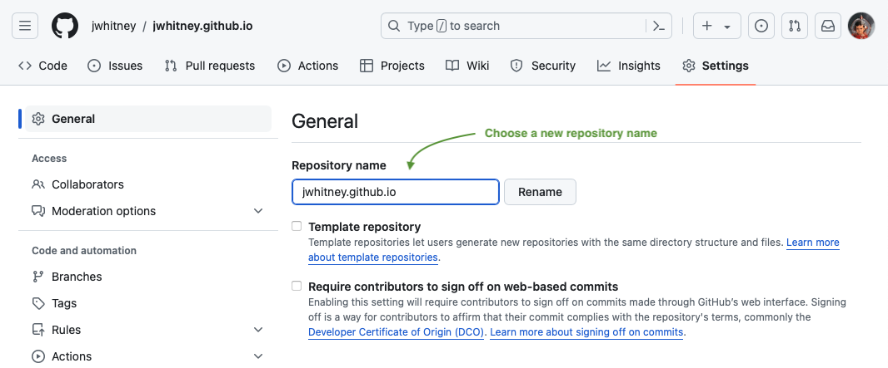

* Renaming your earlier repository keeps your work on GitHub and frees up the repository named "username.GitHub.io" to create a new website at https://username.GitHub.io.

**Step 2**. Create your own copy of the academicpages.GitHub.io repository.

* Go to [https://GitHub.com/academicpages/academicpages.GitHub.io](https://github.com/academicpages/academicpages.github.io). Select "Use this template", then choose "Create a new repository":

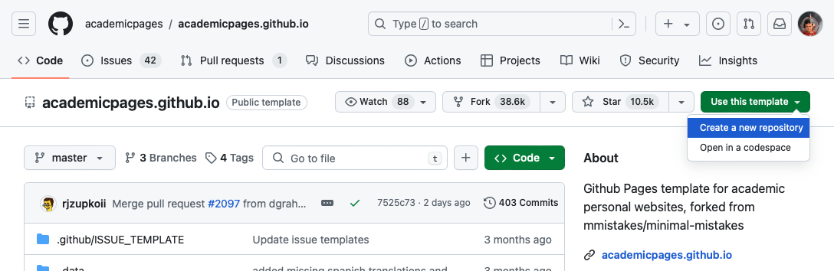

* Name the new repository "**username.GitHub.io**":

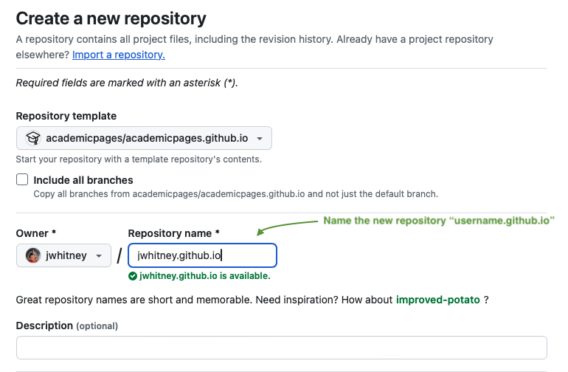

* Add a description of your new repository (optional), then choose "Create repository."

**Step 3**. Rename branch to "main"

* Starting in 2020, new GitHub repositories have a "main" branch, as part of broader changes across the tech sector to remove outdated and harmful terminology. The academicpages.GitHub.io, created before 2020, still uses the outdated "master" branch name.
* This step changes the branch name in your copy of the repository from "master" to "main." Select the "master" branch name:

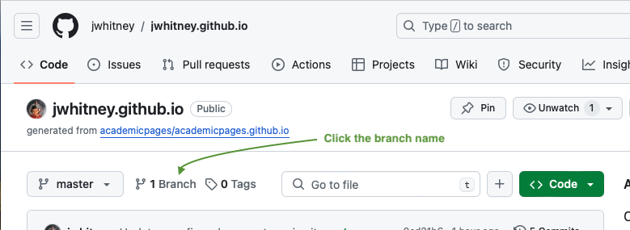

* On the Branches page, select the menu to the right of the branch name, then choose **Rename branch**:

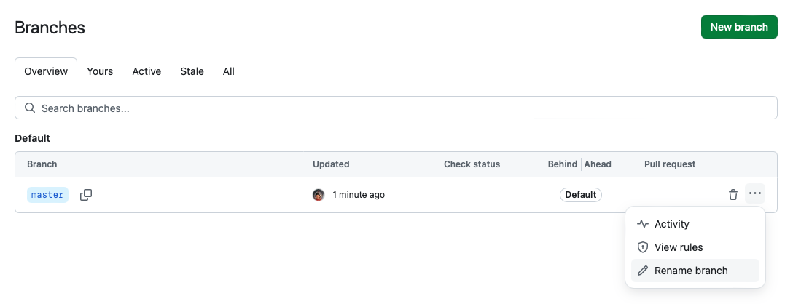

* In the popup, enter "main" as the new branch name, then choose **Rename branch**:

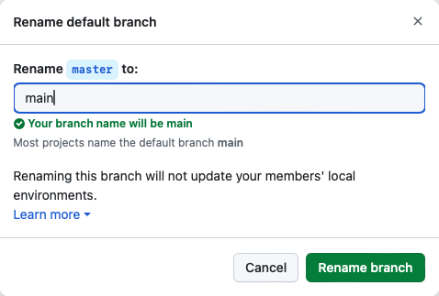

* After renaming the branch, GitHub displays a popup warning about renaming local clones. You can ignore this! Click **Ok, got it.**
* Your repository now has a main branch. For background on GitHub's decision to drop outdated terminology, please see [GitHub to replace 'master' with 'main' starting next month](https://www.zdnet.com/article/github-to-replace-master-with-main-starting-next-month/).

**Step 5**. Copy repository files to your laptop.

* Copy repository files from GitHub to your laptop so you can edit website content. Click the Code button at the top right of your repository:

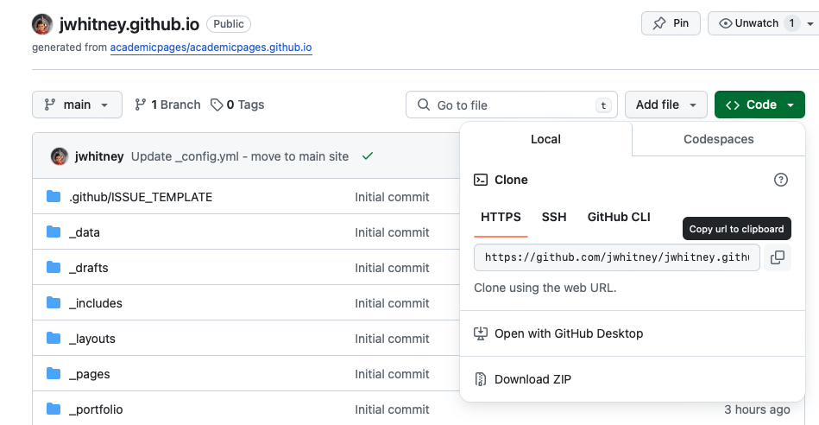

* Make sure the **HTTPS** tab is selected, then copy the URL in the box.
* On your laptop, open the Miniconda terminal. Go to the directory that *contains* your other repositories. E.g., if your folders look like the structure below, go to the **Desktop** directory:

Desktop/

my_first_repository/

interesting_file.md

another_repository/

project_description.md

* Use the following command to copy files from GitHub to your laptop, replacing the URL with the one you've just copied from the **Code** box on GitHub:

git clone https://GitHub.com/username/username.GitHub.io.git

* You should now have a new folder with files from your GitHub repository.

**Step 6**. Edit website files in Visual Studio Code.

* In VS Code, open the directory you've just cloned from GitHub.
* Start editing repository files to customize the website for your academic and research experience. A good place to start is **_config.yml**: edit Basic Site Settings and Author Settings to include your details.
* Try making some changes to the home page: it's in **_pages/about.md**
* After making a few edits, use git commands introduced in the small group exercise to save and sync your work with GitHub:

git add -A

git commit   
git push

**Step 7**. Publish your site with GitHub Pages.

* After pushing your changes to GitHub, view your site online with GitHub Pages.
* Follow the same steps from the small group exercise:
  + Click on **Settings**, in the top navigation.
  + From the left-side menu, click on Pages.
  + Change the source from “None” to the “main” branch, then select **Save** to publish the site.
  + Publish the page.
* View your new site at https://username.GitHub.io

**Step 8**. Keep making changes to your site.

* See the [Academic Pages home page](https://academicpages.github.io) and [Guide](https://academicpages.github.io/markdown/) for help with making changes to your site.
* For an extra challenge, try to generate the Talks map, which shows a map of locations created from information in each page in the _talks directory. See an example here: [https://academicpages.GitHub.io/talkmap.html](https://academicpages.github.io/talkmap.html)